# **Lab: Network Segmentation**

## **Overview**

By designing a network to control how traffic flows among its parts, we can achieve network segmentation. Benefits of segmentation include improvements to operational performance, reduction of cyber attack surface, additional protection for vulnerable devices, and a reduction in scope of regulatory compliance. Today you will practice designing a network to achieve a specified segmentation requirement.

## **Scenario**

Modern switches use virtual local-area networks (VLANs) to improve network performance by separating large Layer 2 broadcast domains into smaller ones. VLANs can also be used as a security measure by controlling which hosts can communicate. In general, VLANs make it easier to design a network to support the goals of an organization.

VLAN trunks are used to span VLANs across multiple devices. Trunks allow the traffic from multiple VLANS to travel over a single link, while keeping the VLAN identification and segmentation intact.

In this lab, you will create VLANs on both switches in the topology, assign VLANs to switch access ports, verify that VLANs are working as expected, and then create a VLAN trunk between the two switches to allow hosts in the same VLAN to communicate through the trunk, regardless of which switch the host is actually attached to.

## **Resources**

* Download Cisco Packet Tracer for your OS from [Cisco Networking Academy](https://skillsforall.com/resources/lab-downloads)
  + This will require you to create an account for Cisco Networking Academy
* [Subnetting Implementation in Cisco Packet Tracer](https://www.geeksforgeeks.org/subnetting-implementation-in-cisco-packet-tracer/)
* [What is VLAN?](https://www.guru99.com/vlan-definition-types-advantages.html#9)
* [Configuring VLANs and Trunking](https://sites.radford.edu/~hlee3/classes/backup/itec451_spring2017/Cisco/CCNA2_RSE_spring2017/Lab%20Source%20Files_solutions/6.2.2.5%20Lab%20-%20Configuring%20VLANs%20and%20Trunking%20-%20solution.pdf)
* [Basic VLAN Configuration](https://courses.cs.ut.ee/2012/NT/juh/3_1.pdf)

## **Objectives**

* Part 1: Build the network and configure basic device settings.
* Part 2: Create VLANs and assign switch ports to the appropriate VLAN.
* Part 3: Configure an 802.1Q trunk between the switches.
* Part 4: Delete the VLAN database.

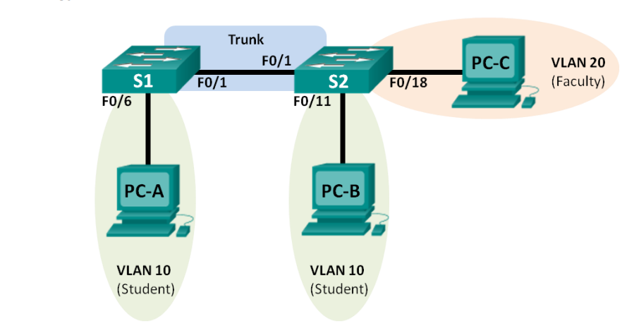

**Addressing Table**

| **Device** | **IP Address** | **Subnet Mask** | **Default Gateway** |
| --- | --- | --- | --- |
| PC-A | 192.168.10.3 | 255.255.255.0 | 192.168.10.1 |
| PC-B | 192.168.10.4 | 255.255.255.0 | 192.168.10.1 |
| PC-C | 192.168.20.3 | 255.255.255.0 | 192.168.20.1 |

## **Tasks**

### **Part 1: Build the network and configure basic device settings.**

Setup the network topology and configure basic settings on the PC hosts and switches.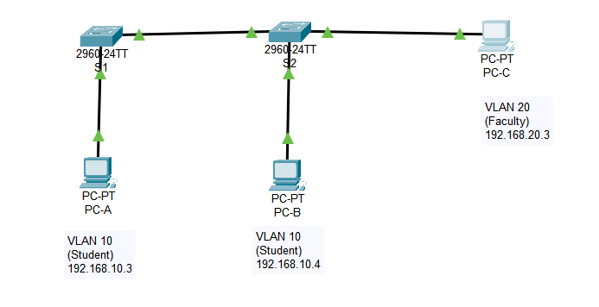

* ~~Deploy the following devices in Packet Tracer:~~
  + ~~2 Cisco 2960 switches~~
  + ~~3 PCs~~
* ~~Attach the devices as shown in the topology diagram.~~
* ~~Initialize the switches as necessary.~~
* ~~Configure PC hosts:~~
  + ~~Refer to the IP addressing table for host address information.~~
    - **~~Note~~**~~: If you try to ping from PC-A to PC-B at this point it will~~ **~~not~~** ~~work~~

**Here I clearly show that PC-A thru PC-C have all the correct settings (I know it says PC-3, but that was before I noticed they had specific names. I fixed it.)**

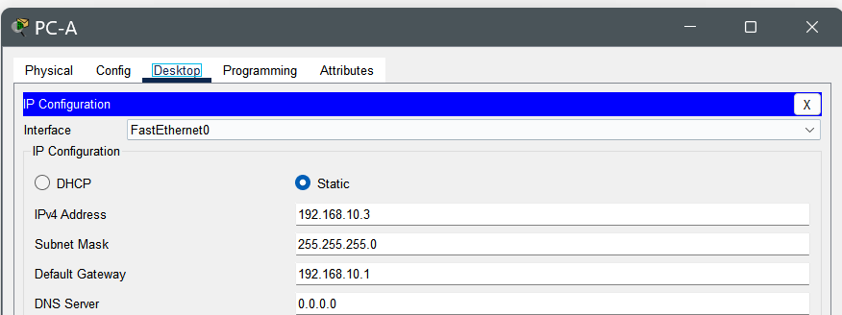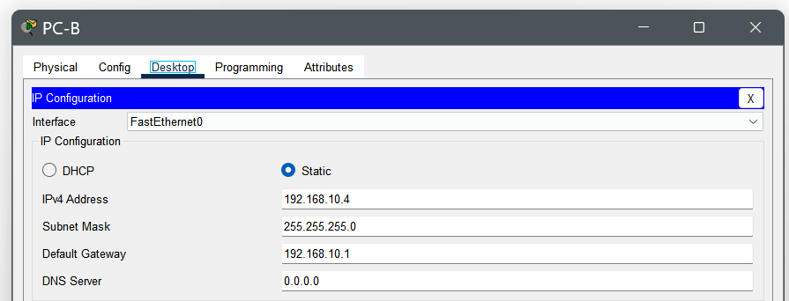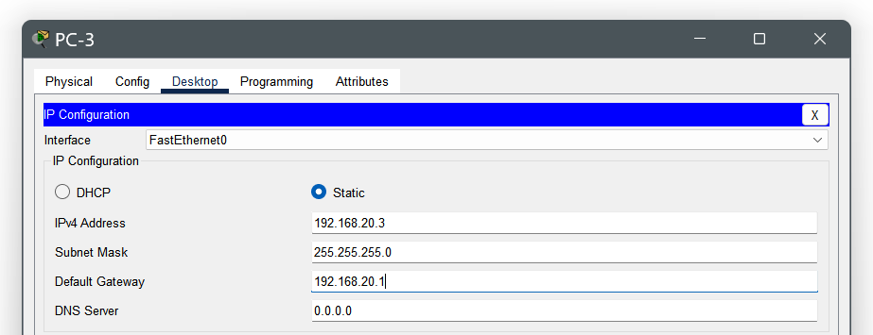

### **Part 2: Create VLANs and assign switch ports.**

* ~~Create a student and a faculty VLAN on the appropriate switch and assign the VLANs to the appropriate interfaces~~
* ~~Create VLANs on the switches (S1 and S2).~~
  + ~~On S1 create the student VLAN (VLAN 10)~~
  + ~~On S2 create both the student (VLAN 10) and the faculty VLAN (VLAN 20)~~

**S1 is switch 1, S2 is switch 2. This screenshot shows that the VLANs are created and available as per the instructions. Additionally, they clearly show that both switches are set to “Trunk” required in one of the following steps**

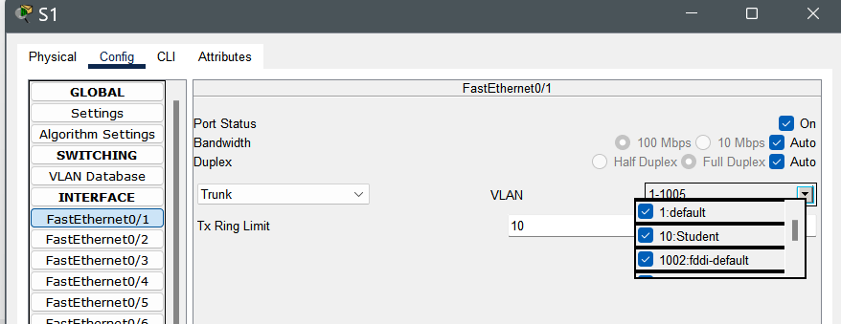

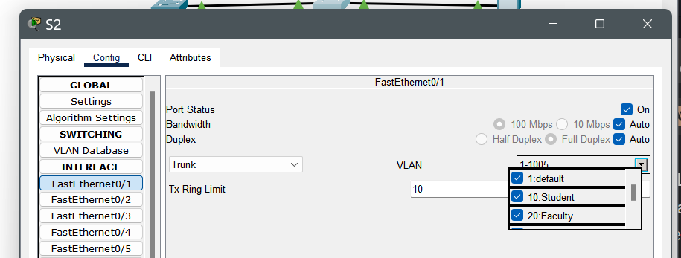

* ~~Assign VLANs to the correct switch interfaces.~~
  + ~~Assign PC-A to the student VLAN.~~
  + ~~Use the topology to assign VLANs to the appropriate ports on S2.~~

### **Part 3: Configure an 802.1Q Trunk between the switches.**

* ~~Configure an interface to use Dynamic Trunk Protocol (DTP) so it can negotiate the trunk mode.~~
* ~~Manually configure trunk interface F0/1.~~
  + ~~Change the switchport mode on interface F0/1 to trunking. Make sure to do this on both switches.~~

**Same screenshot again…why? Because its a screenshot that does a lot of work. Trunks!**





* ~~Verify that PC-A and PC-B are sharing a connection by pinging between them, and verify that PC-C is on a different VLAN by confirming that ping attempts between it and the student PCs fail.~~

**They can communicate! I pinged the hell out of some fake PCs, on a fake network, inside a program on my computer.**

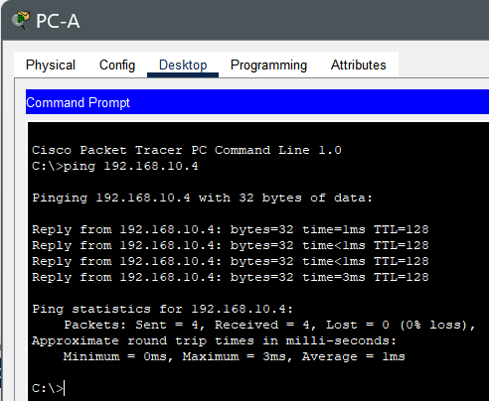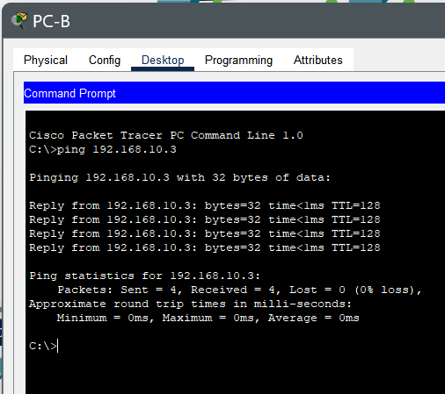

**PC-C Can’t communicate! PC-C is for losers**

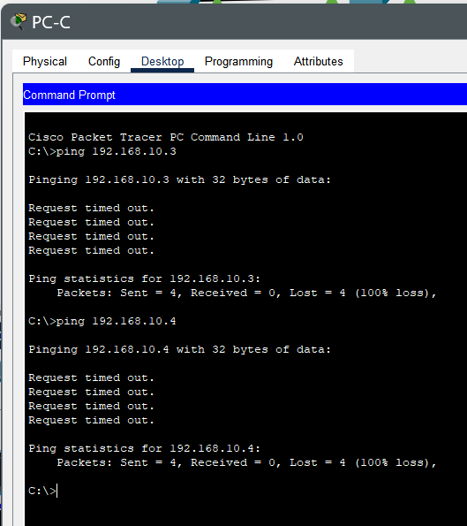

**All done! This task took 15 minutes, I appreciate an easy lab as much as the next guy, but seriously?**